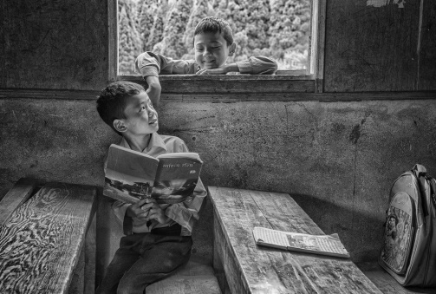

**Mr. Abhishek Banerjee**

**“HAPPY TOO DISTURB”**

**“TWO DIFFERENT READERS”**

**India**

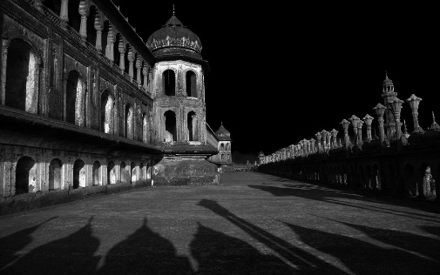

**Mr. Ajaish Jaiswal**

**“Domes Minertas of Bada Imambada”**

**India**

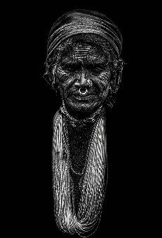

**Mr. Akash Chauhan**

**“PEACE OF OLDNESS”**

**India**

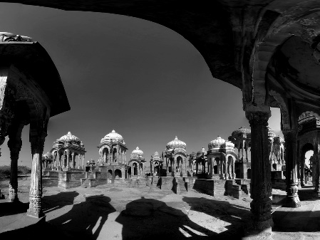

**Mr. Akhil Hardia**

AFIAP, AIIPC, FIP 4 Star

**“Historical”**

**India**

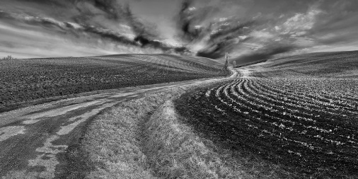

**Mr. Alain Morata**

EFIAP, EFPF

**“COURBES NB”**

**France**

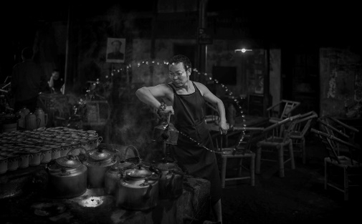

**Mr. Alexandrinolei Airosa**

**“Sprinkle water 04”**

**Macau S. A. R.**

**MONOCHROME OPEN - ACCEPTANCES**

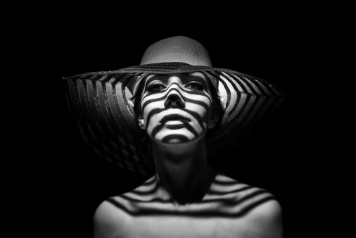

**Mr. Alexey Suloev**

**“Summer style”**

**“Fitzroy”**

**Russia**

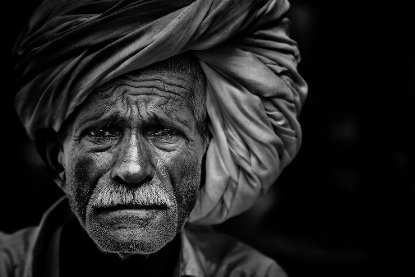

**Dr. Amit Bijon Dutta**

AFIAP, FFIP, GPU CR1, FICS

**“Jwellery Girl1”**

**“Portrait Traditional”**

**India**

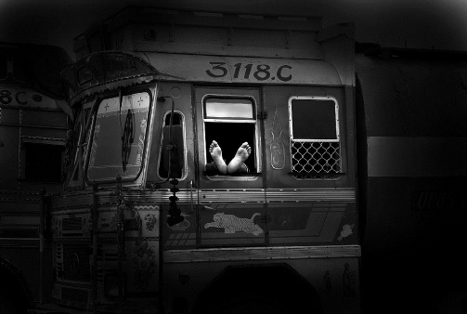

**Mr. Anil Mehrotra**

**“At Rest”**

**India**

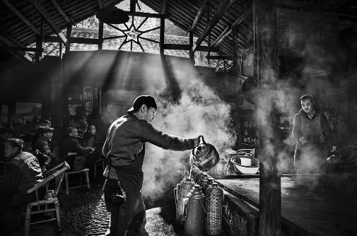

**Mr. Arnaldo Paulo Che**

**“Happy childhood 3” (FIAP Gold - Best Image)**

**“Yi Peng festival 2” (FIP Gold - Best Celebration)**

**“Horse looping 3” (PSA HM Ribbon)**

**“Old tea house 19”**

**Hong Kong S. A. R.**

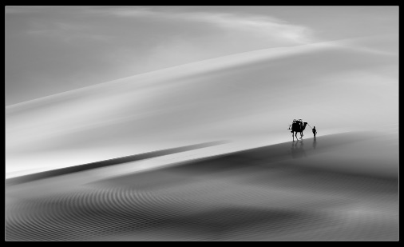

**Mr. Asit Kumar Ray**

EFIAP, FFIP

**“LOOSEN UP1”**

**“HORIZON1”**

**“BONDING”**

**India**

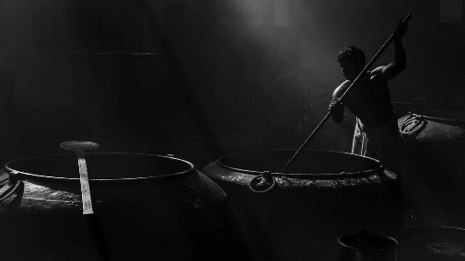

**Mr. Astro Mohan**

FICS, FIIPC, AFIP, ASOF

**“Let me cook”**

**India**

**MONOCHROME OPEN - ACCEPTANCES**

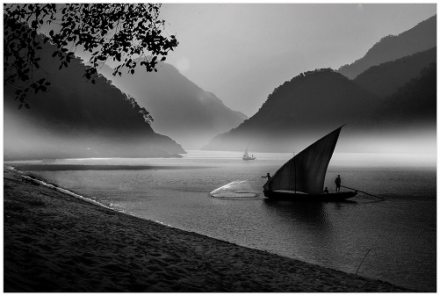

**Mr. Basudeb Chakraborty**

EFIAP, FFIP, LIIPC

**“3RD GENERATION”**

**“FISHING IN THE MIST”**

**India**

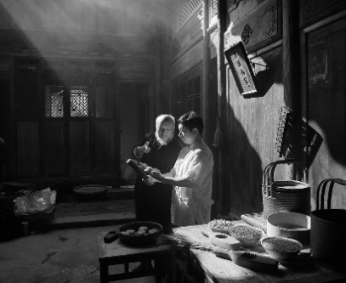

**Mr. Chunling Li**

**“inherit”**

**“naughty”**

**China**

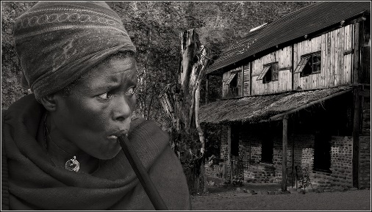

**Mr. Claude Simon**

EFIAP/g, BEPSS

**“Fear before nightfall”**

**“Luna old castle”**

**Belgium**

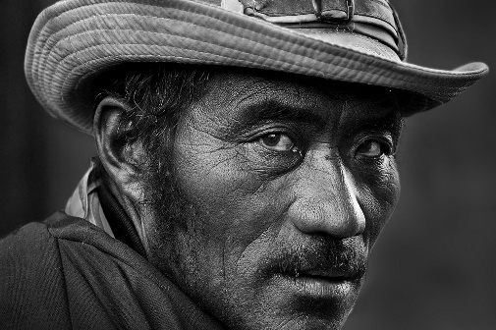

**Mr. Clement Carol**

AFIAP, LRPS, SPSA, GPSA

**“LEH MAN”**

**“SMILE”**

**India**

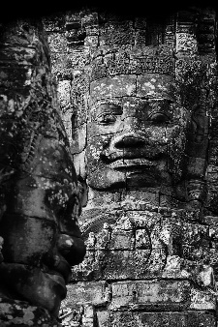

**Mr. Deepak Vinjamoor Murali**

**“Everlasting Smile”**

**India**

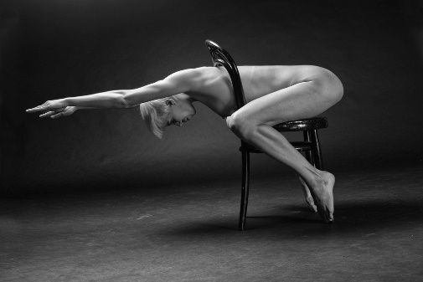

**Mr. Diederik Van Rompaey**

“**LEGS WORKOUT”**

**“HIDING FOR LIGHT”**

**“STOELENDANS”**

**Belgium**

**MONOCHROME OPEN - ACCEPTANCES**

**MONOCHROME OPEN - ACCEPTANCES**

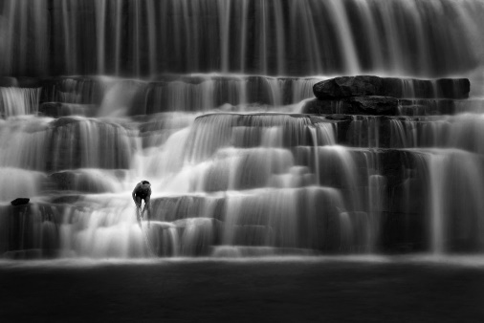

**Mr. Digwas Bellemane**

**“Hungry Egret”**

**“Fisherman”**

**India**

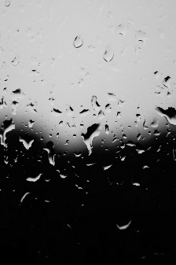

**Mr. Dipesh Kumar Guria**

**“Phoenix”**

**India**

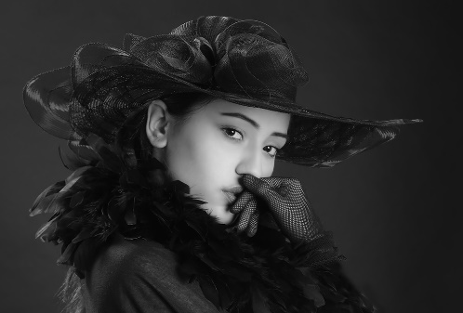

**Mr. Giap Chiu Teo**

GMPSA/B, EFIAP/b

**“Ceana Teo Xianeng bw”**

**Singapore**

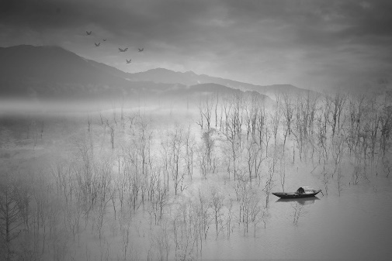

**Mr. Goutam Kumar Dutta**

**“CONNECTING GOD”**

**“SOLITARY”**

**India**

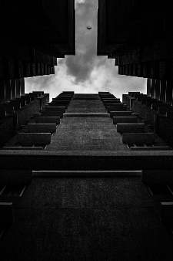

**Mr. Hardik Shah**

**“Guftagu”**

**India**

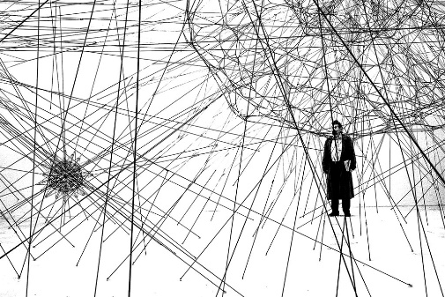

**Mrs. Helgard Quandt**

PPSA

**“Gefangen im Netz”**

**“Lange Allee”**

**Germany**

**MONOCHROME OPEN - ACCEPTANCES**

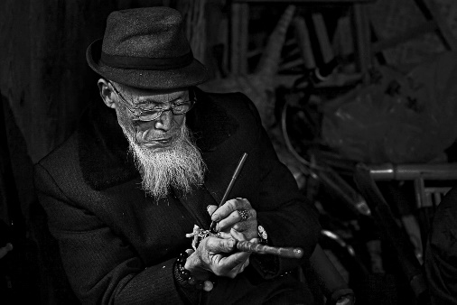

**Mr. Hsiu Chin Lee**

**“Butter tea”**

**“Focus on07”**

**Taiwan**

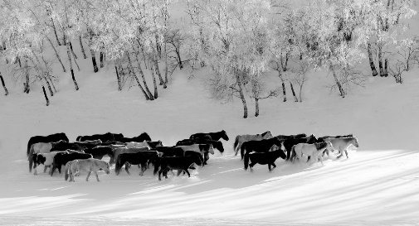

**Mr. Hui Wang**

**“Way to home”**

**“The Belt and Road”**

**China**

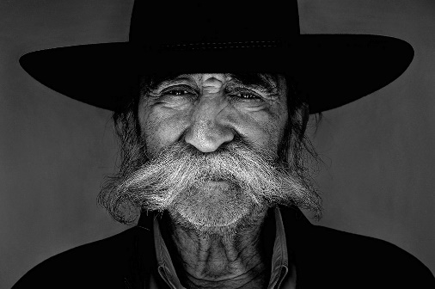

**Mr. Kerekes Istvan**

EFIAP/d1

**“Yelena” (FIAP Ribbon)**

**“Kayak slalom”**

**“Gabor gipsy”**

**Hungary**

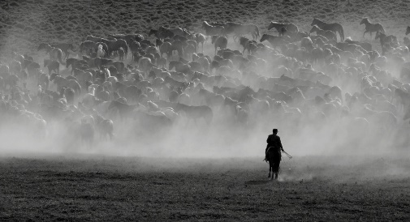

**Mr. Jiahu She**

**“Grazing rider”**

**China**

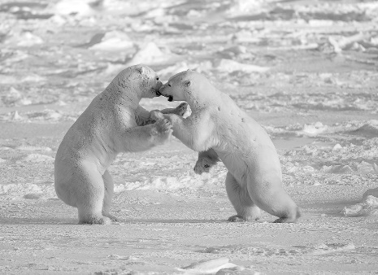

**Mrs. Jingru Luo**

**“Boxing”**

**United States**

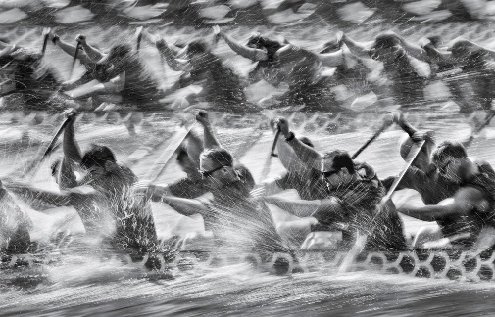

**Mr. Kam Chiu Tam**

**“Revenging” (FIAP Silver - 3rd Best Image)**

**“I will win” (PSA HM Ribbon)**

**“Racing at Welland”**

**Canada**

**MONOCHROME OPEN - ACCEPTANCES**

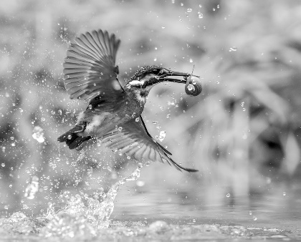

**Mr. Koon Nam Cheung**

MPSA, EFIAP, ARPS

**“Good Lunch 17 BW”**

**Hong Kong S. A. R.**

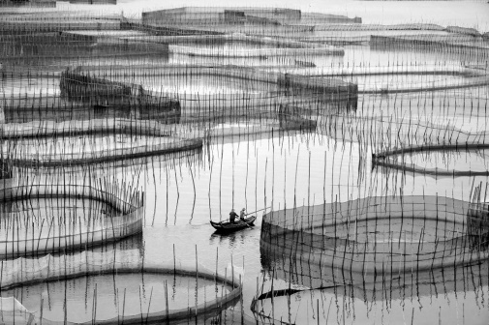

**Ms. Lanfeng Chen**

**“Transition a” (YPS Bronze - Best Light & Shadow Image)**

**“Shrimp net”**

**“Lonely forward”**

**China**

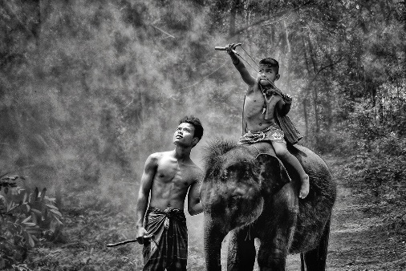

**Ms. Lee Eng Tan**

**“Guilin Net bw”**

**“Lady with Elephant”**

**“Young Mahout”**

**Singapore**

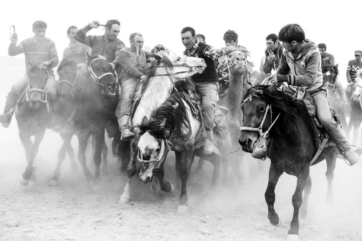

**Ms. Li Fang**

**“Grabing sheep3”**

**“Monther and daughter doing needle work2”**

**China**

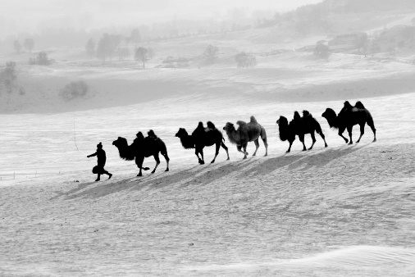

**Ms. Li Wang**

EPSA

**“Camels Walking BashangBW”**

**“Snowy Woods”**

**China**

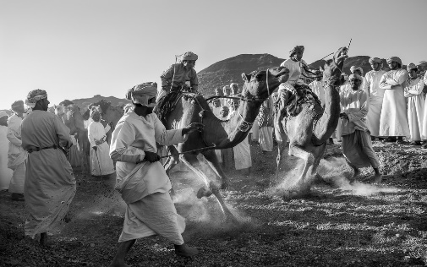

**Mr. Mahalingaraju Kagi**

**“TRADITIONAL CAMEL RACE 4”**

**India**

**MONOCHROME OPEN - ACCEPTANCES**

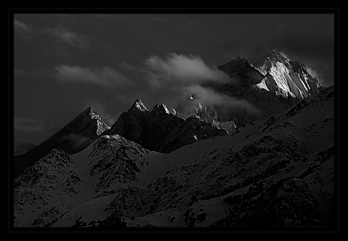

**Mrs. Manisha Patil**

**“MY STYLE”**

**“TWINS”**

**“MAJICAL HIMALAYA”**

**India**

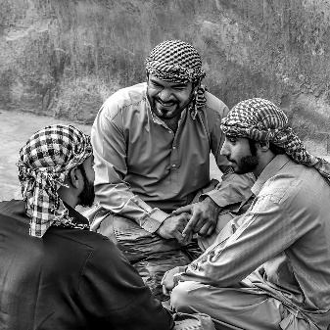

**Mr. Manoj Kumar V K**

APSNJ, FICS

**“Friends Chat”**

**India**

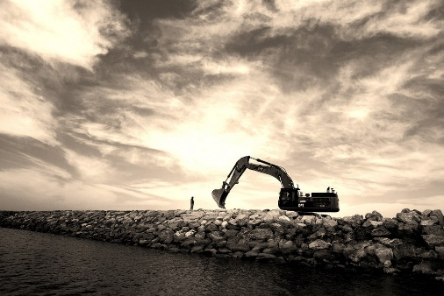

**Mr. Manu Reghuarajan**

ARPS

**“Miles to go” (FIAP Ribbon)**

**“On the rocks”**

**India**

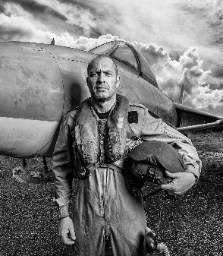

**Mrs. Marielaure Stone**

EFIAP/p, DPAGB, BPE5

**“Aviator”**

**“Myanmar Chin tribe tattoed elder”**

**United Kingdom**

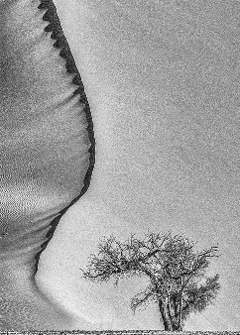

**Mrs. Maureen Toft**

EFIAP/p, MPAGB, MPSA

**“Dune Tree”**

**United Kingdom**

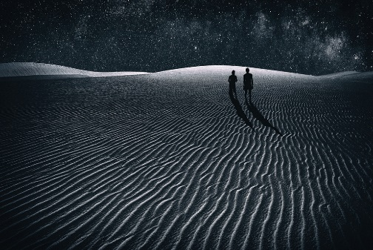

**Mr. Mohammed Ibrahim**

**“Conversation”**

**“In Search Of New Universe”**

**India**

**MONOCHROME OPEN - ACCEPTANCES**

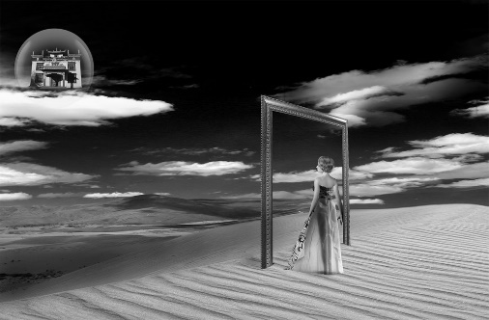

**Mr. Mukta Biswas**

EFIAP

**“WAY TO DREAM LAND”**

**India**

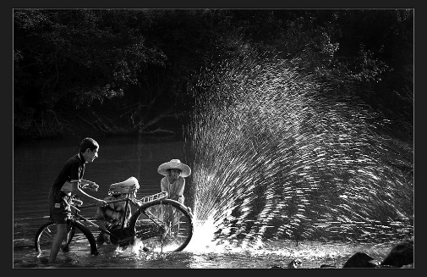

**Mr. Nagendra Muthmurdu**

AFIAP

**“Fun in pondB1”**

**“Nuthatch Chicks QuarellingB1”**

**India**

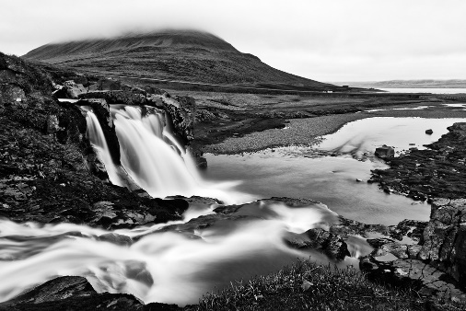

**Mr. Nicolas Raymond**

**“Foggy Kirkjufellsfoss BW”**

**United States**

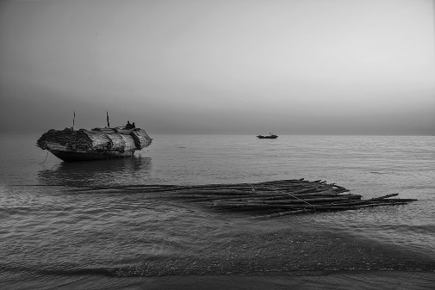

**Mr. Nirmalya Bhattacharya**

EFIAP

**“THE STREET DWELLER” (FIAP Ribbon)**

**“GIRL AND THE NET”**

**“THE BOAT”**

**“WOMAN IN WEB”**

**India**

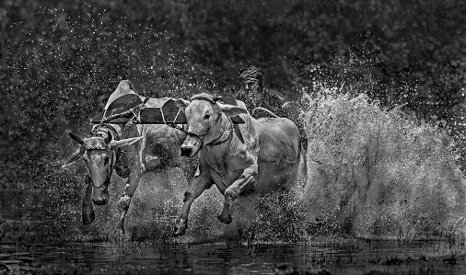

**Mrs. Nivedita Dutta**

**“Look Up”**

**“Moichara”**

**India**

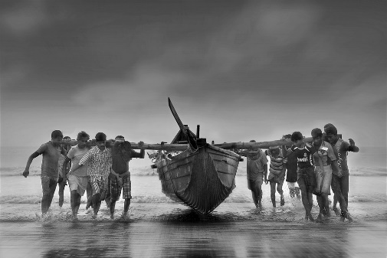

**Ms. Niyanta Modak**

**“JOINT EFFORT”**

**India**

**MONOCHROME OPEN - ACCEPTANCES**

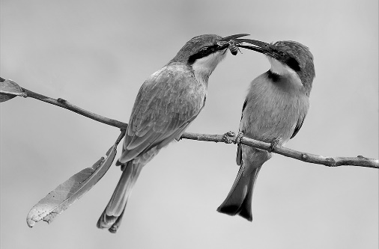

**Mr. Phillip Kwan**

GMPSA/B, FRPS

**“Little Beeeater Sharing BW”**

**Canada**

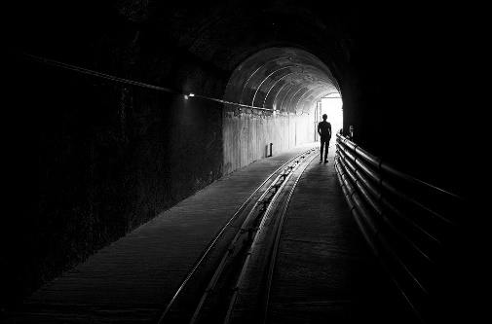

**Mr. Pradipta Chakraborty**

**“ALONE”**

**India**

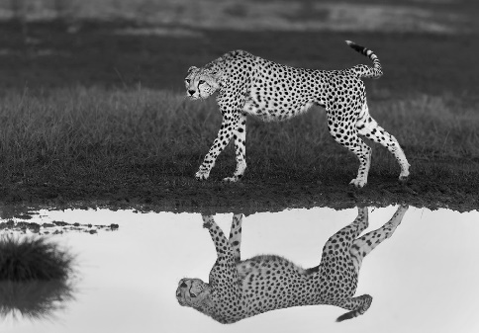

**Mr. Pramod Govind Shanbhag**

ARPS, EFIAP

**“Cheetah with reflection”**

**“Dialogue in the air”**

**India**

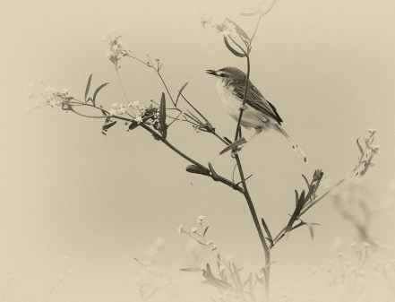

**Mr. Prasad Pudukota Sampath**

**“Sweetie Pie”**

**India**

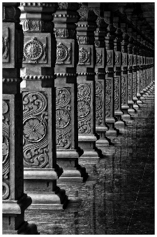

**Mr. Prateek Patnaik**

**“Pillars Of Antarvedi Temple”**

**India**

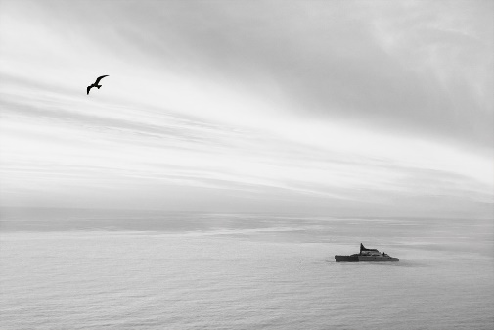

**Mrs. Priyanshi Nahata**

AICS, APSNJ

**“Infinite”**

**India**

**MONOCHROME OPEN - ACCEPTANCES**

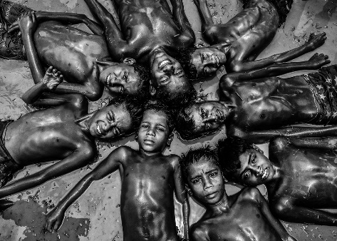

**Mr. Pushpendu Paul**

AFIP

**“HELP ME JESUS”**

**“A BUNCH OF EXPRESSIONS”**

**“SAVING MY FRIEND FALTU”**

**India**

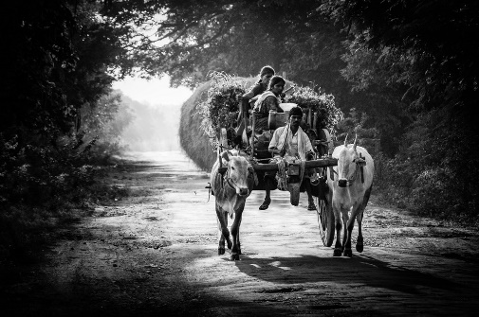

**Mr. Raghavendra Naik**

**“Treading Homely path”**

**India**

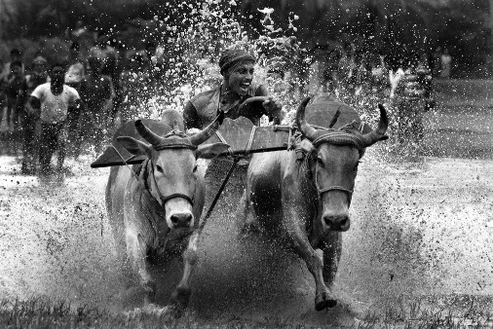

**Mr. Rajarshi Sengupta**

**“I am the Winner”**

**India**

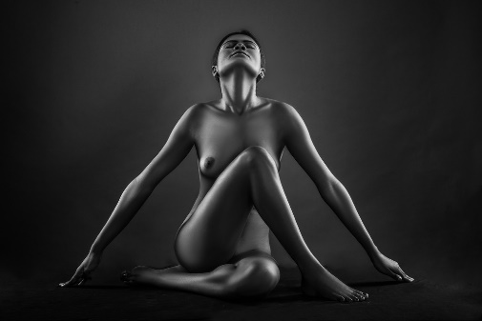

**Mr. Rajdeep Biswas**

EFIAP, Hon PESGSPC, SSS/Y

**“FS 6667”**

**“FS 7251”**

**“FS 6782”**

**“Geometry 1”**

**India**

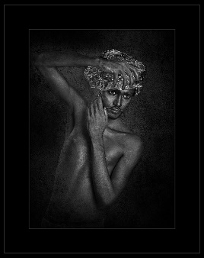

**Mr. Rakesh Rawal**

**“SYMMETRY” (PSA HM Ribbon)**

**“MONU AS A CHROME”**

**India**

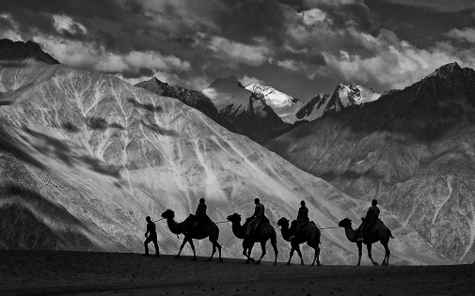

**Mr. Raviraj Joshi**

**“Silk Route”**

**India**

**MONOCHROME OPEN - ACCEPTANCES**

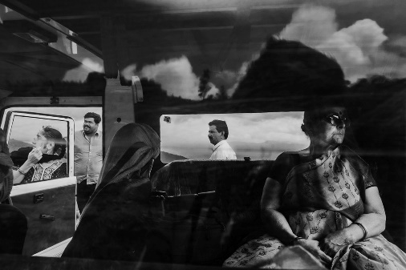

**Mr. Ritagnik Bhattacharya**

**“Layers of the mind”**

**India**

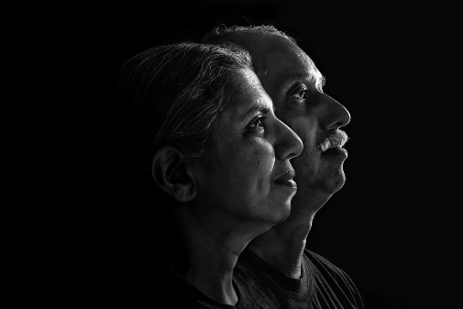

**Mr. Ruben Alexander**

**“Petty Narcissist”**

**“Stalwarts “**

**India**

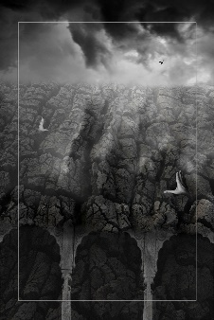

**Mr. Sadhan Kumar Deb**

**“The Saviour Cloud”**

**India**

**Mr. Saibal Mondal**

**“Midday Fishing”**

**“Ritratte 9541”**

**“Ritratti MC 5026”**

**“CHILD TWO SMILE MC 7336”**

**India**

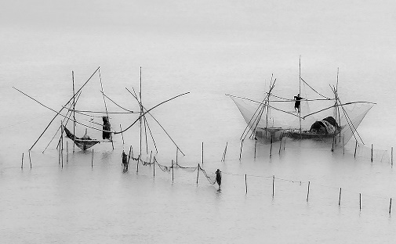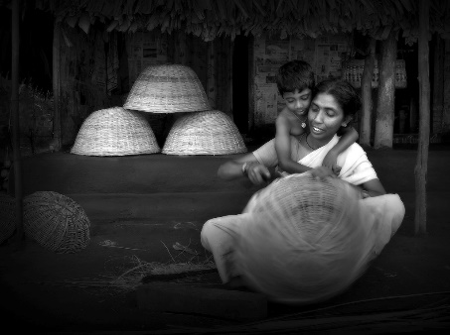

**Mr. Sainadh Mallula**

AICS

**“Mother at work”**

**“Born free”**

**India**

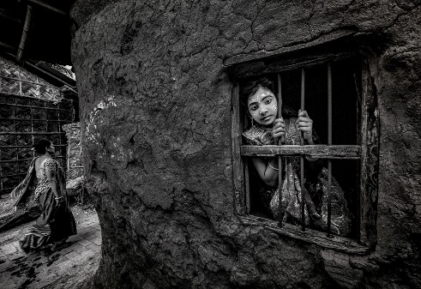

**Dr. Sanjib Basak**

GPU CR1

**“WAITING”**

**India**

**MONOCHROME OPEN - ACCEPTANCES**

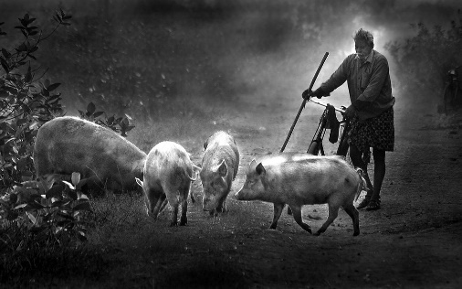

**Mr. Saraswatirao Korlapati**

AIIPC, AFIP

**“PIGS”**

**India**

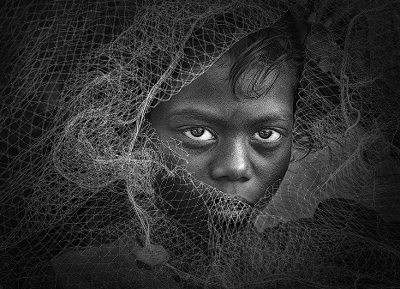

**Mrs. Saswati Chakraborty**

EFIAP

**“ETERNAL BOND” (FIAP Ribbon)**

**“GIRL WITH NET”**

**India**

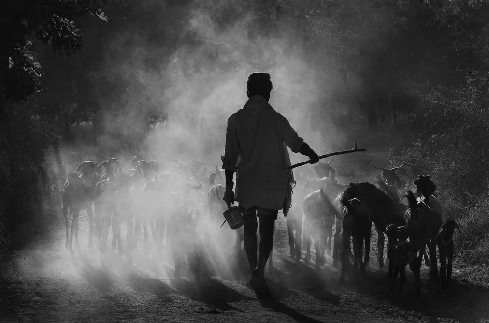

**Mr. Sathyanarayana C R**

EFIAP, ARPS, FICS, Hon FPSG

**“LINEMAN” (FIAP Bronze - Best Character Portrait)**

**“RETURNING HERD”**

**India**

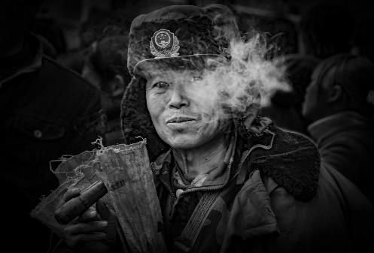

**Mr. Shenghua Yang**

**“Running horses BW”**

**“Western Hunan villager”**

**China**

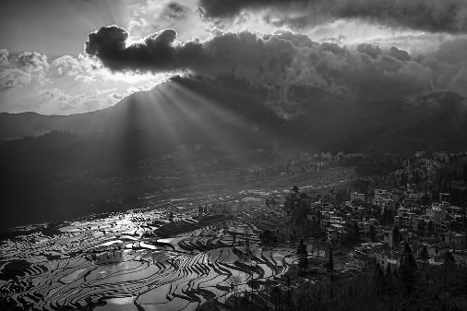

**Mr. Shibu Mathew**

LRPS, EFIAP

**“Rays on Houses”**

**India**

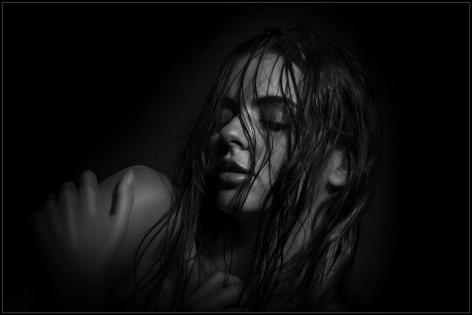

**Mr. Shirish Jhaveri**

AIIPC, FFIP, Hon PSI

**“SEXIEST”**

**“READY TO SHOOT 2”**

**India**

**MONOCHROME OPEN - ACCEPTANCES**

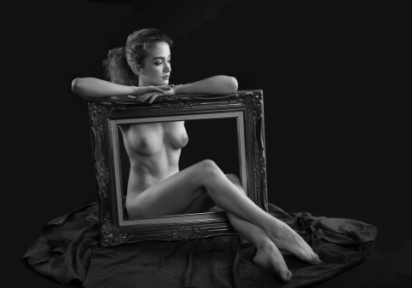

**Mr. Shiu Gun Wong**

Hon FRPS, FPSA, FBIPP

**“Bridal Bliss” (FIAP Ribbon)**

**“Sleeping Beauty”**

**“All Wet 2”**

**“Gina 2”**

**Hong Kong S.A.R.**

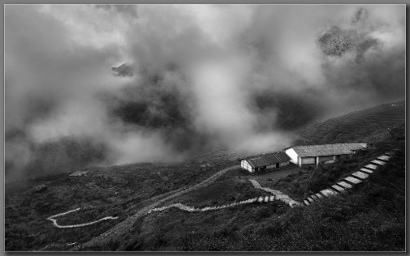

**Mr. Shuvashis Saha**

**“Granny at Darjeeling”**

**“Misty Valley”**

**India**

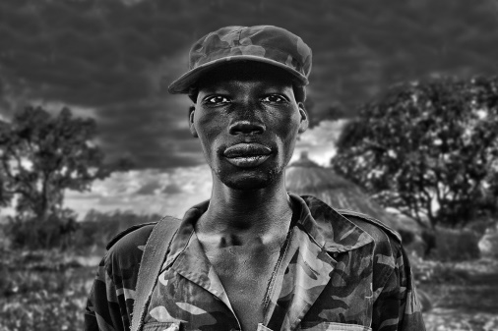

**Mr. Silvano Monchi**

AFIAP, Hon EFIAP

**“Kumi”**

**“Prigioniero Ugandese”**

**Italy**

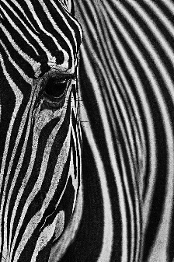

**Mr. Sounak Banerjee**

AFIP

**“Stripes of Nature”**

**“Shadows and Stairs”**

**India**

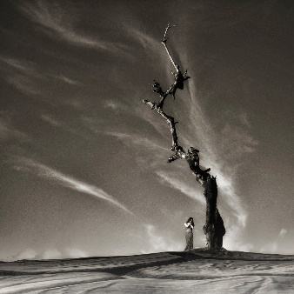

**Mr. S P Mukherji**

EFIAP, AIIPC, IIPC Platinum, Hon PESGSPC

**“Life At Foothill 3” (PSA Gold - 2nd Best Image)**

**“Shattered Love”**

**India**

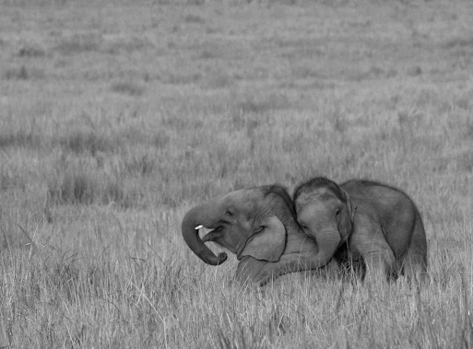

**Mr. S P Nagendra**

EFIAP, ARPS

**“MY MUMMY”**

**“LIFE WITH WILD”**

**India**

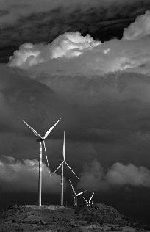

**Mr. Srinivas K S**

AFIAP

**“wind mill”**

**India**

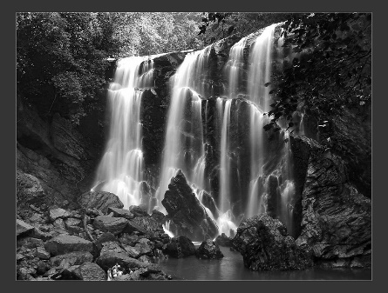

**Mr. Suhas Muthmurdu**

**“Affection”**

**“Satoddi”**

**India**

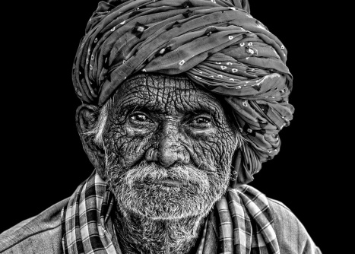

**Mr. Suman Chattopadhyay**

**“WAVE OF TIME”**

**India**

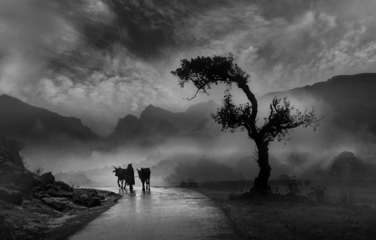

**Mr. Suresh Bangera**

**“Kambala” (YPS Gold - Best Sports)**

**“If this happened” (YPS Silver - Best Digital Creation)**

**“black girl”**

**“cloudy weather”**

**India**

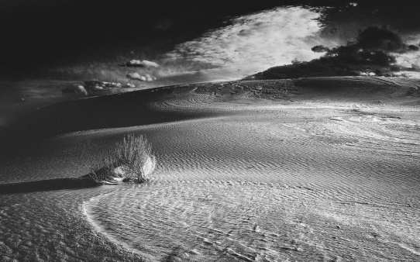

**Mr. Thejas Rajaram**

**“slow beach” (PSA Silver - Best Landscape)**

**“drama in the desert”**

**India**

**Mr. Thigh Wanna**

**“The lady 2M”**

**“Mount bromo 4M”**

**Singapore**

**MONOCHROME OPEN - ACCEPTANCES**



**MONOCHROME OPEN - ACCEPTANCES**

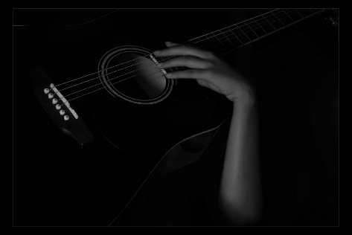

**Dr. Tulika Sahu**

**“Play on”**

**India**

**Mr. V D Bhat Sugavi**

**“Expectation”**

**“GOD GIFT”**

**India**

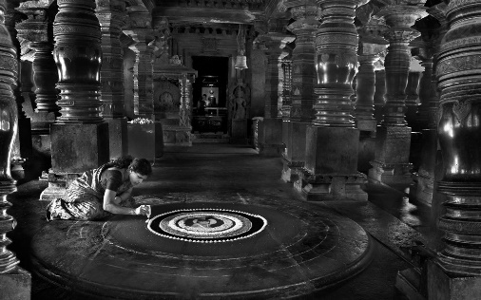

**Mr. Vadivelu T T**

**“Air Of Tranquility”**

**India**

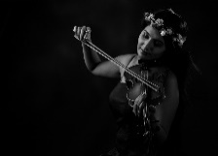

**Mr. Varadanayaka Varadraj**

**“Bicycle ride” (FIAP Ribbon)**

**“Kambala”**

**“Raining”**

**India**

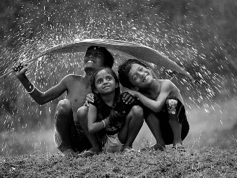

**Mr. Vinod Chauhan**

AFIAP, AFIP, FFIP, AIIPC, AEAIP, FICS, RSOF, FSOF, EIUP, Hon AIUP

**“PURITY IN THE WOODS”**

**“HUSTLER”**

**India**

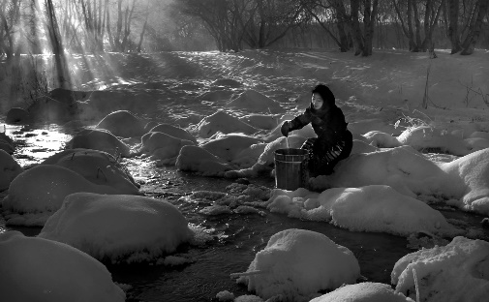

**Mr. VKRS Sarma**

AFIAP

**“TWIN CARRYING”**

**“LONG CATCH”**

**India**

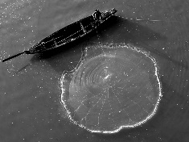

**MONOCHROME OPEN - ACCEPTANCES**

**Ms. Xiaomei Xu**

**“High land face”**

**“Twilight dating”**

**China**

